# **Smoking Cessation Program**

Assumption: Passive smoking ignored

* Term & WL
* Hypothetically: Up to 50% reduction in mortality
* [**PMC: Age as a Predictor of Quit Attempts and Quit Success in Smoking Cessation**](https://www.ncbi.nlm.nih.gov/pmc/articles/PMC5695521/) **(2021)**
  + - International Tobacco Control Policy Cohort Survey
    - 2002-2014 Data: 15,874 of the US, Australia, UK and Canada adults
    - Findings
      * The younger the age group, the more quit attempts/ interest
        + Except 55+ years (cessation program not as effective at reducing mortality at this age though)
      * Percentage of quit attempts among daily smokers
        + Age 18-24: 49.6%
        + Age 25-39: 41.4%
        + Age 40-54: 36.9%
        + Age 55+: 39.4%
        + 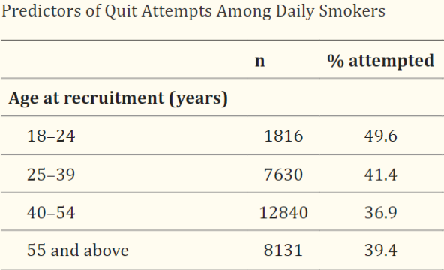
        + Note: data was 30,417 episodes with 13,450 smokers
      * ‘Episode’ is an instance of someone making a quit attempt. A single participant can have multiple episodes over the duration of the study
        + Important data considering smoking program may involve multiple attempts – unlike other interventions
    - Data limitations
      * The findings of the study are based on a large, representative survey of the adult population of England mainly
      * Quit behaviors were self-reported, raising questions of differences in recall or reporting behavior among older smokers
* [**JAMA Network: Association Between Smoking, Smoking Cessation, and Mortality by Race, Ethnicity, and Sex Among US Adults**](https://jamanetwork.com/journals/jamanetworkopen/fullarticle/2797597) **(2022)**
  + - US National Health Interview Survey
    - 1997-2018 Data: 551,338 of the US adults
    - Findings
      * **Assumption**: cessation program was successful
        + Must determine program success rate (huge range)
      * Largest health gains from ceasing is for younger age groups
      * All-cause mortality relative risk for current vs never smoker was 2.80 (95% CI, 2.73-2.88)
      * Compared to never smokers the mortality relative risk was...
        + Quit before 35 years old: 1.03 (95% CI, 0.99-1.07): 50%
        + Quit 35 to 44 years: 1.21 (95% CI, 1.17-1.26): 43%
        + Quit 45 to 54 years: 1.47 (95% CI, 1.42-1.53): 35%
        + Quit 55 to 64 years: 1.74 (95% CI, 1.68-1.80): 30%
        + **Note:** Quit smoking means stopped at least 5 years before
        + Evidence (another source) -> mortality rate <https://www.bmj.com/content/355/bmj.i6468#:~:text=The%20mortality%20rate%20was%20more,0.64%20(0.61%20to%200.67>)).
    - Data limitations
      * Info collected at same time, so cessation or relapse after the info was collected is ignored
      * Did not separate participants with and without existing disease at recruitment
      * Not incorporate geospatial variables (e.g. tobacco policies etc.)
  + [**https://www.ncbi.nlm.nih.gov/pmc/articles/PMC5394024/**](https://www.ncbi.nlm.nih.gov/pmc/articles/PMC5394024/) **(2015)**
    - Reduction of 30-50% in mortality in lung cancer mortality in last 10 years
* [**https://www.cdc.gov/tobacco/data_statistics/fact_sheets/adult_data/cig_smoking/index.htm**](https://www.cdc.gov/tobacco/data_statistics/fact_sheets/adult_data/cig_smoking/index.htm)
  + - Correlating proportion of smokers in each age group
    - By Sex2
    - Current cigarette smoking was higher among men than women.
      * About 13 of every 100 adult men (13.1%)
      * About 10 of every 100 adult women (10.1%)
    - By Age2
    - Current cigarette smoking was highest among people aged 25–44 years and 45–64 years. Current cigarette smoking was lowest among people aged 18-24 years.
      * About 5 of every 100 adults aged 18–24 years (5.3%)
      * Nearly 13 of every 100 adults aged 25–44 years (12.6%)
      * Nearly 15 of every 100 adults aged 45–64 years (14.9%)
      * About 8 of every 100 adults aged 65 years and older (8.3%)
* [Incentives for smoking cessation (2019)](https://www.ncbi.nlm.nih.gov/pmc/articles/PMC6635501/#:~:text=Quitting%20smoking%20can%20greatly%20improve,and%20sometimes%20as%20community%20programmes)
  + Cochrane Tobacco Addiction Group Specialised Register & International Clinical Trials Registry Platform Data ( - 2018)
  + Data: 21,600 individuals from USA, Thailand, EU, Phillipines
  + Findings
    - Types of incentives
      * Overall monetary incentive is preferred
    - No effect between trials offering low or high total amounts of incentives, nor those encouraging redeemable self‐deposits --> cessation rate similar
      * Incentives studied ranged between USD 45 and USD 1185
      * Difficult to determine due to monetary value differing in different countries and each different program details
    - Effectiveness of incentives appears to be sustained even when the last follow-up occurs after the withdrawal of incentives
      * Incentives mainly needed to support the initial difficult months
    - 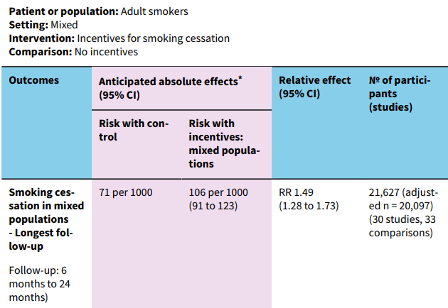
    - Comparison to smokers with no incentives vs incentive (7.1% quit vs 10.6% quit)
  + Data limitations
* [Lottery incentives for smoking cessation at the workplace (2023)](https://bmcpublichealth.biomedcentral.com/articles/10.1186/s12889-022-14915-x)
  + Solely here to support previous study/findings
    - Same conclusion that no clear association between quit-rates and incentive size --> other important design features influence cessation rate
* [Design of Financial Incentive Programs for Smoking Cessation (2022)](https://www.ncbi.nlm.nih.gov/pmc/articles/PMC9575978/)
  + Data limit: Significantly smaller study
  + Data: 430 from UK
  + Findings:
    - Preferred higher amounts over lower amounts
    - Cash over vouchers
    - Consistent amounts over an escalating schedule
    - Willingness to enroll increased quadratically with the incentive amount, although this increase slowed for higher amounts
    - Middle- and high-income smokers preferred slightly higher amounts
* <https://economictimes.indiatimes.com/wealth/insure/life-insurance/you-can-save-80-on-your-term-life-insurance-premium-if-you-quit-smoking-when-and-how-to-buy-it/articleshow/102713832.cms?from=mdr>

# Incentive for Preventative Screening

* Whole life
* Issue age group: 35-65
* Hypothetically: 5-10% reduction in mortality
* [**BMC Medicine: NHS Health Check attendance is associated with reduced multiorgan disease risk**](https://bmcmedicine.biomedcentral.com/articles/10.1186/s12916-023-03187-w) **(2024)**
  + UK Biobank data
  + 2006-2022 Data: 48,602 UK’s National Health Check (NHS) recipients
  + Based on NHS Health Check
    - UK’s free preventative health screening for 40-74 years every 5 years
  + Findings
    - 2 years after NHS Health Check --> higher diagnosis rates were observed for hypertension, high cholesterol, and chronic kidney disease and fatty liver disease (as seen in figure below)
    - However, after 2 years --> significantly lower risk across all multiorgan disease outcomes and reduced rates of cardiovascular and all-cause mortality

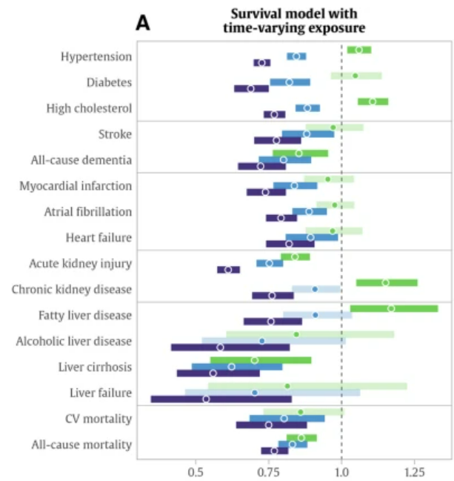

* + - 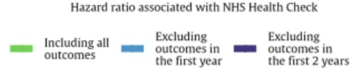
    - All-cause mortality relative rate lowers by 23% lower, with hazard ratio of 0.77
    - Note: Argument to push for heart health screening intervention still after general health check
      * Out of 9 lowest affected issues by hazard ratio --> 4 are heart related diseases (i.e. CV, heart failure, atrial fibrillation, high cholesterol). Thus, requires a heart screening too.
  + Data limitations
    - Only NHS UK policy and data related
    - Data included repeated screenings for some recipients
      * May not follow our intervention program

<https://www1.racgp.org.au/newsgp/clinical/preventive-health-checks-linked-to-lower-mortality>

23% reduction in mortality

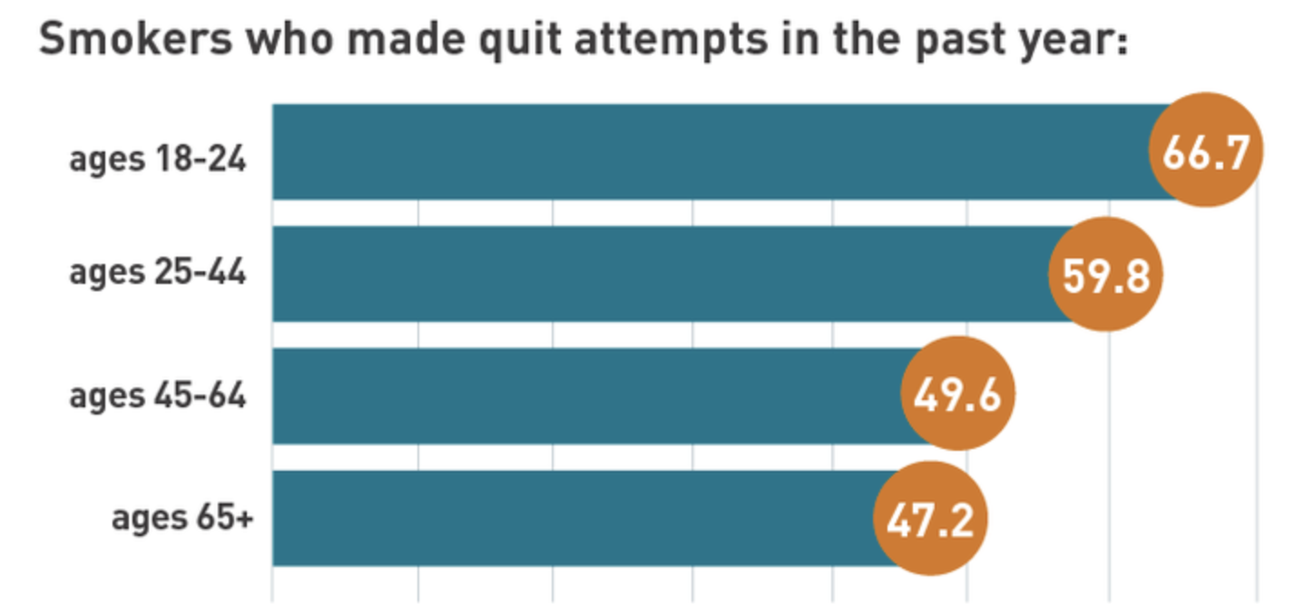

<https://truthinitiative.org/research-resources/quitting-smoking-vaping/what-you-need-know-quit-smoking>

Smokers who made attmpt to quit

# Heart Hearth Screenings

* Heart Health Screenings
  + Whole life
  + Issue age group: 35-65
  + 5-10% reduction in mortality
  + External research: which age mortality reduction related
  + [The impact of population screening for cardiovascular disease on quality of life](https://www.ncbi.nlm.nih.gov/pmc/articles/PMC10246813/#oead055-B2)
    - 11% all cause mortality reduction
  + [Articles needed]
  + <https://www.ncbi.nlm.nih.gov/pmc/articles/PMC5217841/>
  + chrome-extension://bdfcnmeidppjeaggnmidamkiddifkdib/viewer.html?file=https://www.york.ac.uk/media/crd/ehc16.pdf

Shows heart screening isnt really impactful.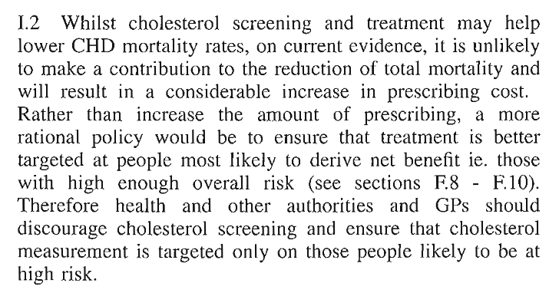

Found similar result from different studies too

* + https://centralgaheart.com/need-heart-health-screenings/#:~:text=Through%20regular%20heart%20health%20screenings,Franklin%2C%20Ph.
  + <https://www.news-medical.net/news/20220828/Cardiovascular-screening-may-lower-the-risk-of-death-heart-attack-and-stroke-in-65-to-69-year-olds.aspx>
    - 45000 men study, shows 11% reduction in mortality for age 65 to 69
    - 7% decrease overall across the whole population